PCI DSS Network Segmentation
Complete Implementation Guide
A GRC Project Documentation & Best Practices
Document Version: 1.0
Prepared Date: February 12, 2026
Prepared By: Siddique Reza Khan
Dedicated to: Taimur Ijlal

Table of Contents
Project Overview 4
Project Objectives 4
Section 1: Understanding PCI DSS Scope 5
1.1 What is PCI DSS Scope? 5
Cardholder Data Includes: 5
Sensitive Authentication Data: 5
1.2 Three Categories of Systems 5
1.3 Scoping Methodology 6
Section 2: Network Segmentation Fundamentals 8
2.1 What is Network Segmentation? 8
2.2 Benefits of Segmentation 8
2.3 Segmentation Methods 8
Section 3: Implementing Network Segmentation 10
3.1 Planning Phase 10
Step 1: Define Segmentation Strategy 10
Step 2: Network Design 10
Step 3: Security Controls Planning 10
3.2 Implementation Phase 10
Firewall Rule Principles 10
Example Firewall Rules 10
Section 4: Segmentation Testing 11
4.1 PCI DSS Requirement 11.4.5 11
4.2 Testing Methodology 11
4.3 Testing Scenarios 12
Section 5: Documentation Requirements 13
5.1 Essential Documentation 13
5.2 Scope Determination Template 13
Section 6: Ongoing Maintenance 14
6.1 Regular Activities 14
6.2 Change Management 14
Section 7: Best Practices 15
7.1 Design Principles 15
7.2 Implementation Tips 15
Section 8: Practical Implementation Example 16
8.1 Example Scenario 16
8.2 Network Segmentation Design 16
Conclusion 18
Appendices 19
Appendix A: Glossary 19
Appendix B: Implementation Checklist 20
Appendix C: Resources 20

Project Overview
This comprehensive guide provides step-by-step instructions for completing a PCI DSS Network Segmentation project. Network segmentation is a critical security control that isolates the Cardholder Data Environment (CDE) from other network components, reducing PCI DSS scope and enhancing security posture.

Project Objectives
- Define and document PCI DSS scope boundaries
- Implement effective network segmentation controls
- Validate segmentation effectiveness through testing
- Reduce PCI DSS assessment scope
- Enhance security by limiting potential attack paths
- Create comprehensive documentation for auditors

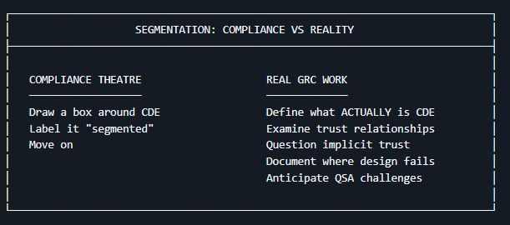

Section 1: Understanding PCI DSS Scope

1.1 What is PCI DSS Scope?
PCI DSS scope encompasses all system components that store, process, or transmit cardholder data (CHD), or could impact the security of the Cardholder Data Environment.

Cardholder Data Includes:
- Primary Account Number (PAN)
- Cardholder Name
- Expiration Date
- Service Code

Sensitive Authentication Data:
- Full magnetic stripe data
- CAV2/CVC2/CVV2/CID
- PINs and PIN blocks

1.2 Three Categories of Systems
Category | Description
In-Scope Systems | Systems that store, process, or transmit cardholder data. Examples: Payment terminals, POS systems, payment gateways, databases with CHD, applications processing payments.
Connected Systems | Systems that connect to or can impact in-scope systems. Examples: Network devices providing connectivity, security systems protecting CDE, management systems with CDE access.
Out-of-Scope Systems | Systems completely isolated from the CDE with no connection or access path to cardholder data. Cannot impact CDE security.

1.3 Scoping Methodology
Step | Activities
Step 1: Data Discovery | Identify all locations where cardholder data exists, map data flows throughout organization, document all systems touching CHD
Step 2: Asset Inventory | Create comprehensive inventory of all systems, document network connectivity, identify system owners and purposes
Step 3: Data Flow Analysis | Map how cardholder data moves through systems, identify all processing points, document transmission methods and protocols
Step 4: Boundary Definition | Define clear boundaries of the CDE, identify all connection points, document segmentation controls

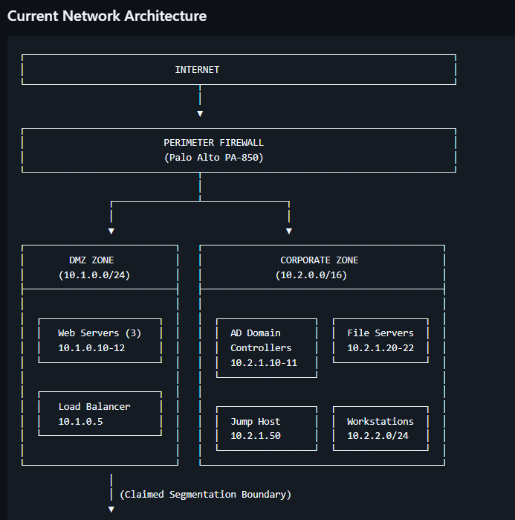

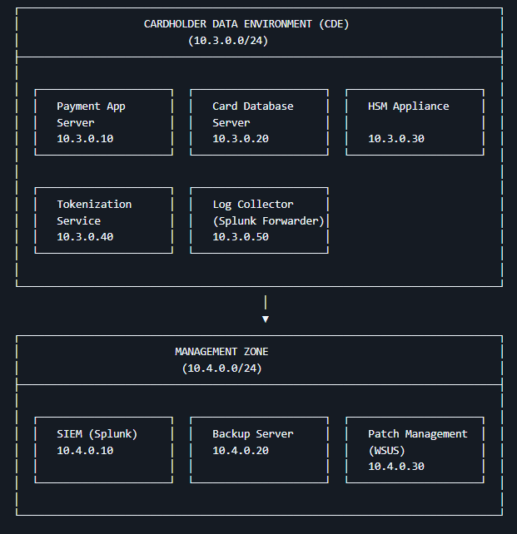

Section 2: Network Segmentation Fundamentals

2.1 What is Network Segmentation?
Network segmentation divides a computer network into smaller, isolated sections. In PCI DSS context, it separates the CDE from other network segments to:
- Reduce assessment scope
- Limit lateral movement in case of breach
- Focus security resources on critical systems
- Simplify compliance efforts

2.2 Benefits of Segmentation
Security Benefits | Compliance Benefits | Operational Benefits
• Contains breaches  • Reduces attack surface  • Limits lateral movement  • Improves detection | • Reduces in-scope systems  • Decreases audit complexity  • Lowers compliance costs  • Simplifies evidence | • Improves performance  • Enables targeted controls  • Facilitates troubleshooting  • Flexible security policies

2.3 Segmentation Methods
Method | Description | Characteristics
Physical Segmentation | Completely separate hardware and network infrastructure with no physical connection | • Highest isolation  • Most expensive  • Complete separation
Logical Segmentation | VLANs, firewalls with strict rules, NAC, Software-Defined Networking | • Cost effective  • Flexible  • Requires proper config
Hybrid Approach | Combination of physical and logical controls | • Most common  • Balances security/cost  • Practical

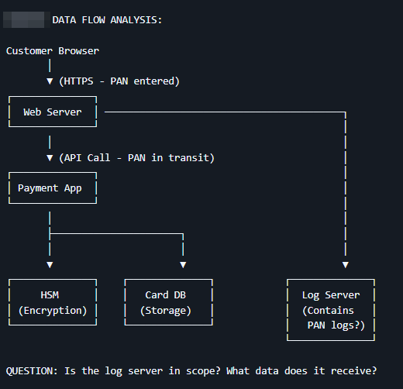

Section 3: Implementing Network Segmentation

3.1 Planning Phase

Step 1: Define Segmentation Strategy
- Identify segmentation objectives
- Select appropriate segmentation methods
- Define segment boundaries
- Plan for future growth

Step 2: Network Design
- Create network architecture diagrams
- Define subnet structures
- Plan IP addressing scheme
- Design firewall rule sets

Step 3: Security Controls Planning
- Identify required security controls
- Plan firewall configurations
- Design access control policies
- Plan monitoring and logging

3.2 Implementation Phase

Firewall Rule Principles
- Default deny all traffic
- Explicitly allow only necessary traffic
- Document all rules with business justification
- Review rules at least every 6 months

Example Firewall Rules
Rule | Description | Justification | Review Date
permit tcp 192.168.1.0/24 host 10.0.1.100 eq 443 | Allow web servers to payment gateway | Process credit card transactions | 2026-08-01
permit tcp host 192.168.1.50 host 10.0.1.200 eq 3306 | Allow app server to CDE database | Retrieve transaction data | 2026-08-01
deny ip any 10.0.1.0/24 | Deny all other CDE access | Default deny security | 2026-08-01

Section 4: Segmentation Testing

4.1 PCI DSS Requirement 11.4.5
Requirement: Segmentation controls are tested as follows:
- At least every six months and after any changes to segmentation controls/methods
- By an internal qualified resource or external third party
- To confirm that segmentation is effective

4.2 Testing Methodology
Phase | Activities
Phase 1: Planning | Define test scope, identify test systems, obtain necessary approvals, schedule testing window
Phase 2: Reconnaissance | Network mapping, service discovery, vulnerability scanning, information gathering
Phase 3: Testing | Attempt CDE access from outside, test firewall rules, attempt to bypass controls, test all documented paths
Phase 4: Reporting | Document findings, classify vulnerabilities, provide remediation guidance, create executive summary

4.3 Testing Scenarios
Scenario | Objective | Expected Result
External to CDE | Verify external networks cannot access CDE. Test: ping CDE, connect to services, scan ports, access applications | All attempts fail
Guest WiFi to CDE | Verify guest network isolation from CDE. Test: access CDE IPs, routing, DNS lookups, corporate resources | Complete isolation
Workstation to CDE | Verify workstations cannot directly access CDE. Test: access systems, databases, unauthorized pathways | Access denied
Lateral Movement | Verify segmentation limits lateral movement. Test: privilege escalation, pivot to CDE, vulnerable pathways | Unable to reach CDE
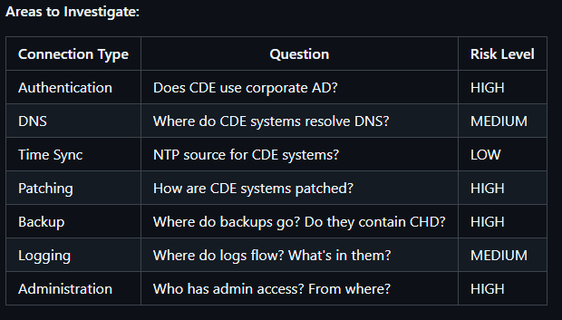

Section 5: Documentation Requirements

5.1 Essential Documentation
Document Type | Required Contents
Network Diagrams | Current state architecture, logical topology, physical layout, data flow diagrams, segmentation boundaries clearly marked
Firewall Documentation | Complete rule sets, rule justifications, review dates and ownership, change history, testing results
Scope Documentation | System inventory, in-scope system list, connected system list, out-of-scope justification, scope validation evidence
Testing Documentation | Test plans and procedures, testing results and evidence, remediation records, re-test results, sign-off documentation

5.2 Scope Determination Template
Use this template to document your PCI DSS scope determination:
System Name | Description | Location | CHD Status
[System 1] | [Description] | [Location] | [Yes/No]
[System 2] | [Description] | [Location] | [Yes/No]
[System 3] | [Description] | [Location] | [Yes/No]

Section 6: Ongoing Maintenance

6.1 Regular Activities
Frequency | Activities
Monthly | Review firewall logs, check for unauthorized changes, verify monitoring is active, review access logs
Quarterly | Review and update network diagrams, validate scope boundaries, review firewall rules, test key segmentation controls
Semi-Annually | Conduct full segmentation testing, review all documentation, update risk assessments, validate control effectiveness
Annually | Complete PCI DSS assessment, review segmentation strategy, update policies and procedures, comprehensive security review

6.2 Change Management
All Changes Require:
- Change request documentation
- Security impact assessment
- Testing before implementation
- Updated documentation
- Rollback plan
- Post-implementation validation

Section 7: Best Practices

7.1 Design Principles
Principle | Description
Defense in Depth | Multiple layers of security controls to protect against various attack vectors
Least Privilege | Provide only the minimum access necessary for users and systems to perform their functions
Zero Trust | Verify everything, trust nothing. Authenticate and authorize every access request
Simplicity | Simple designs are easier to secure, maintain, and troubleshoot
Documentation | Maintain comprehensive and current documentation for all systems and processes

7.2 Implementation Tips
- Start with clear scope definition
- Document everything from the beginning
- Test before production deployment
- Implement change management early
- Train staff on new procedures
- Plan for ongoing maintenance
- Build relationships with auditors

Section 8: Practical Implementation Example

8.1 Example Scenario
Aspect | Details
Organization | Mid-sized retail company with e-commerce operations
Challenge | E-commerce website shares infrastructure with corporate network, increasing PCI scope
Goal | Implement segmentation to reduce PCI scope and improve security posture

8.2 Network Segmentation Design
Segment | Network | Purpose
CDE Segment | 10.0.1.0/24 | Payment processing systems only, strict firewall controls, no direct internet access, dedicated monitoring
DMZ Segment | 10.0.2.0/24 | Web and application servers, limited CDE access, internet-facing
Corporate Segment | 192.168.1.0/24 | Employee workstations, no CDE access, standard security controls
Management Segment | 10.0.3.0/24 | IT administration, jump boxes for CDE access, enhanced logging

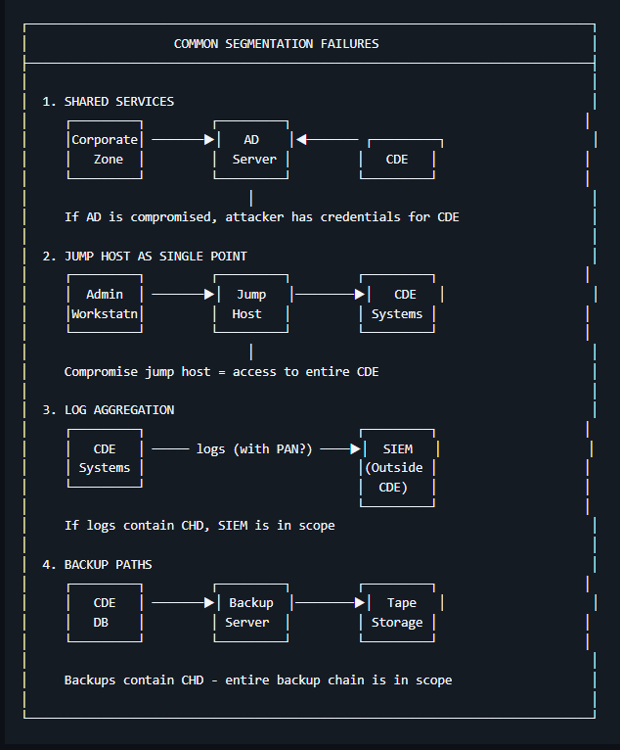

Conclusion
Implementing effective network segmentation for PCI DSS compliance requires careful planning, methodical execution, rigorous testing, and ongoing maintenance. This guide provides the foundation for a successful segmentation project that will:
- Reduce PCI DSS scope
- Enhance security posture
- Streamline compliance efforts
- Protect cardholder data
Remember that segmentation is not a one-time project but an ongoing process that requires regular review, testing, and updates to remain effective.

Appendices

Appendix A: Glossary
Term | Definition
CDE | Cardholder Data Environment - Systems that store, process, or transmit cardholder data
CHD | Cardholder Data - Primary account number, cardholder name, expiration date, service code
PAN | Primary Account Number - The unique payment card number
PCI DSS | Payment Card Industry Data Security Standard - Security standard for organizations handling card data
QSA | Qualified Security Assessor - Certified professional who conducts PCI DSS assessments
SAD | Sensitive Authentication Data - Full track data, CAV2/CVC2/CVV2/CID, PINs
VLAN | Virtual Local Area Network - Logical network segmentation on physical infrastructure

Appendix B: Implementation Checklist
Phase | Task | Status
Pre-Implementation | Scope defined and documented | ☐ Complete
Pre-Implementation | Network diagrams created | ☐ Complete
Implementation | Infrastructure deployed | ☐ Complete
Implementation | Firewalls configured | ☐ Complete
Testing | Test plan created and executed | ☐ Complete
Documentation | All documentation completed | ☐ Complete

Appendix C: Resources
Category | Resources
Documentation | PCI DSS v4.0 Requirements, Information Supplement: Scoping and Segmentation, PCI DSS Glossary
Testing Tools | Nmap (network scanning), Metasploit (penetration testing), Wireshark (traffic analysis), Nessus (vulnerability scanning)
Diagramming | Draw.io, Lucidchart, Microsoft Visio
Training | PCI SSC Training Programs, SANS Security Training, (ISC)² Certification Programs, Cloud Security Alliance

END OF DOCUMENT

